Lesson Title: Introduction of Basic Flight Controls – Practical

**Background Context**

Chosen school is Dripstone Middle School. Demographic profile includes 52/48 split of boys and girls. 23% indigenous students and 42% of students with a language background other than English.

Attendance rate is 91%, with a rate of 85% for Indigenous and 92% for Non-Indigenous students. The student attendance level above 90% is 67% for all students, 46% for Indigenous students and 72% for Non-Indigenous. These attendance rates are somewhat above average for the Darwin region.

Likely, as a result of the significant percentage of Indigenous students, Dripstone Middle School has two programs specifically targeting them: CLONTARF and Stars foundation. Clontarf targets males specialising in sporting excellence and Stars targets females to select future careers and to make sound life choices.

Dripstone has a VET program that allows students to contribute to achieving their NTCET whilst continuing traditional school attendance.

|  |  |  |  |
| --- | --- | --- | --- |
| **Year Level:** | 8 | **Length of lesson in minutes:** | 60 |
| **Topic/Theme:** | Remotely Piloted Aircraft | | |
| **Curriculum Learning Area:** | Technologies – Digital Technologies | | |
| **Strand:** | Processes and Production Skills | | |
| **Content Descriptor and Code:** | Analyse and visualise data using a range of software to create information, and use structured data to model objects or events [(ACTDIP026 - Scootle)](http://www.scootle.edu.au/ec/search?accContentId=ACTDIP026)  Acquire data from a range of sources and evaluate authenticity, accuracy and timeliness [(ACTDIP025 - Scootle)](http://www.scootle.edu.au/ec/search?accContentId=ACTDIP025)  Implement and modify programs with user interfaces involving branching, iteration and functions in a general-purpose programming language [(ACTDIP030 - Scootle)](http://www.scootle.edu.au/ec/search?accContentId=ACTDIP030) | | |
| **General Capabilities:** | Personal and Social Capability, ICT Capability, Literacy, Numeracy, Ethical Understanding | | |
| **Learning Intention** | Students are learning to: Control and program an RPA | | |
| **Success Criteria (assessment):** | Students will be able to manoeuvre a quadcopter Remotely Piloted Aircraft (RPA) within a define space, using yaw, pitch, roll and throttle, safely.  Students will be able to program an RPA to using in-built programming to conduct to conduct pre-determined manoeuvre. | | |

**Lesson Sequence:**

|  |  |  |  |
| --- | --- | --- | --- |
| **Timings:** | **Teacher Activity:** | **Student Activity:** | **Resources Required** |
|  | **Hook:** | |  |
| 10 min | With pre-programmed RPA conduct basic manoeuvres that will be performed by students. Then, run programmed movement sequence, to demonstrate final aim of learning. | Student all gathered in a single group, can be sitting or standing, and should be in a shaded area a safe distance from the RPA movement area. | One drone, controlled by the teacher. NB. Do not perform manoeuvres beyond the scope of the lesson, as some students may try to replicate them, increasing the risk to safety. |
|  | **Introduction (Beginning):** | |  |
| 5 min | Explain the manoeuvres to be conducted and the programming sequence, which is reinforced by the movement checklist. | Students will be in a single group for explanation and break into smaller groups with a drone to execute manoeuvres. | One drone per group.  Cones to mark working area. To be laid out prior to lesson.  Checklist of manoeuvres to complete. |
|  | **Building of Lesson (Middle)** | |  |
| 35 min | Ensure groups are working safely within the limits of the activity.  Ensure groups are achieving the checklist outcomes.  NB. Do not become too invested in single groups, as an RPA can become dangerous if not monitored closely.  Another supervisor may be required, depending on student numbers and behaviour. | Students working in pairs or groups of 3 will be given an RPA to manoeuvre within a defined space. Students will be given instructions to follow, step-by-step, to control the drone and achieve each of the movements.  This will build on a previous lesson about the basic flight controls of an RPA by applying practical skills and how they apply to the RPA.  The movements and controls will have been taught, in theory, during the previous lesson. Further, demonstrations will have also been given, either physically or through video. Whilst it is preferable to demonstrate the manoeuvres practically, by the teacher, however it may not be feasible due to time or the size of the class. |  |
|  | **Conclusion/Summary (End)** | |  |
| 10 min | Collect student movement checklists or verbally confirm with students, what stage they achieved. | Students pack up drone and other equipment and return to a single area for discussion about the manoeuvres they were able to complete or had difficulty with. |  |

**Reflection/Notes:**

|  |  |
| --- | --- |
| **How do you know if the lesson went well?** | Confirm proposed flight area is safe and clear of obstacles or other traffic, ground and air. Refer to [CASA](https://www.casa.gov.au/drones).  Check RPA serviceability, this will also be done during a theory lesson with students.  Ensure suitable separation is achieved between RPA operators and RPAs.  Review whether time was sufficient to allow all students to complete the manoeuvres.  Preparation and pack up time must also be allowed for within the timetable.  Time has been allowed for in the Unit of Work to repeat this lesson for students to complete manoeuvres or additional practice or may be suitable for a double period, up to 120min. |

**Activity Layout**

AFL field is approximately 100x180m. Students will be spaced at least 20m from one another and 30 m from their and any other RPA movement box. There is expected to be 6 or 7 groups and no more than 8.

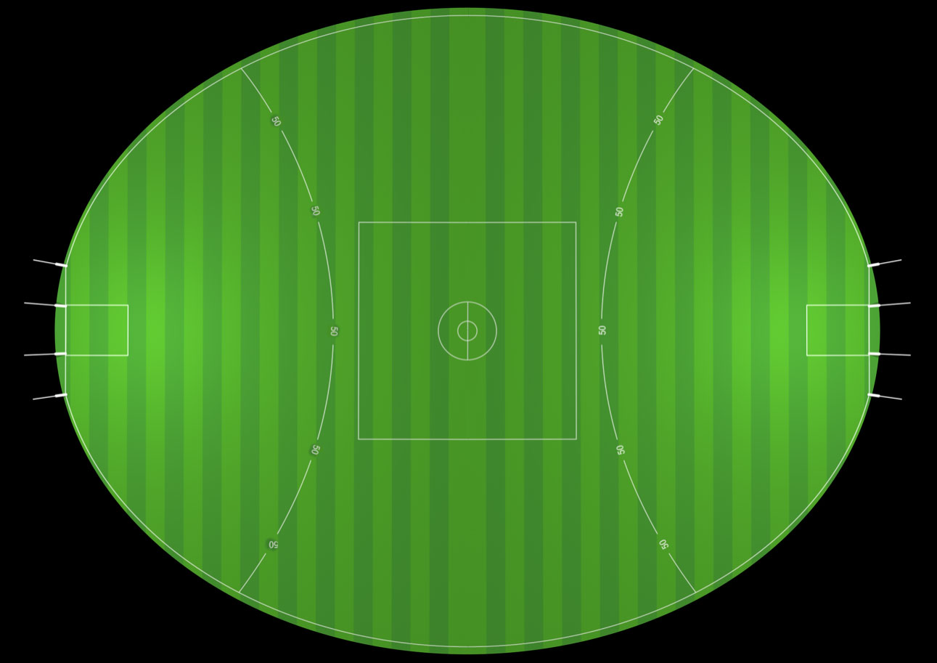

**Movement Box**

**Student Group**